Project Design Phase
Solution Architecture

Date | 30 September 2026
Team ID | SWTID-2026-3555
Project Name | AI Study Buddy
Maximum Marks | 4 Marks

Solution Architecture:
Solution architecture is a complex process – with many sub-processes – that bridges the gap between business problems and technology solutions. Its goals are to:
- Find the best tech solution to solve existing business problems.
- Describe the structure, characteristics, behavior, and other aspects of the software to project stakeholders.
- Define features, development phases, and solution requirements.
- Provide specifications according to which the solution is defined, managed, and delivered.

AI Study Buddy – Solution Architecture Diagram:

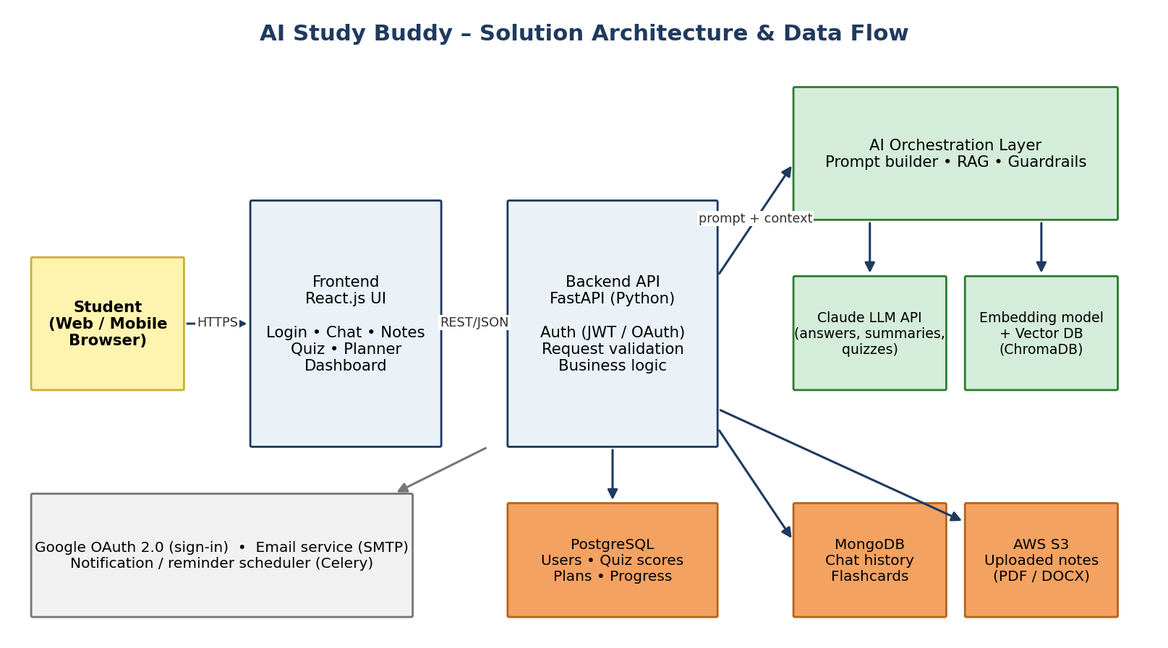
Figure 1: Architecture and data flow of the AI Study Buddy application
Flow: The student uses the React web interface → requests reach the FastAPI backend over HTTPS → the backend authenticates the user (JWT / Google OAuth) → the AI orchestration layer builds the prompt, retrieves relevant note chunks from the vector database (RAG) and calls the Claude LLM API → the response is returned to the student and results (chat history, scores, plans, progress) are stored in PostgreSQL / MongoDB, while uploaded notes are kept in AWS S3.

